Nutrition Blocks

Yu-Ching Ho

14/12/18

**Introduction** **1**

**Game Summary** **1**

**Target Audience** **1**

**Learning Objectives** **2**

**Market Research** **2**

**GUI and Environment** **3**

**Player Mechanics** **4**

**Interactions and Consequences** **5**

**Game Structure** **5**

**Audio** **7**

**Future Work** **7**

**Individual Critical Appraisal** **7**

**Game Development Bugs** **8**

**References** **9**

**Appendix** **9**

# **Introduction**

Nutrition Blocks is a game that will teach players what will happen as a result of different food intake, and see how the food will have an impact on the human body, positively or negatively, and hopefully inspire a healthier diet.

# **Game Summary**

The genre is under the category of Serious Games and Survival, and it will be a game similar to the arcade game Breakout developed by Atari. However, instead of all the blocks being immediately breakable by the ball itself, special blocks will appear as “nutritional blocks” and those can only be broken by switching the ball to match correctly.

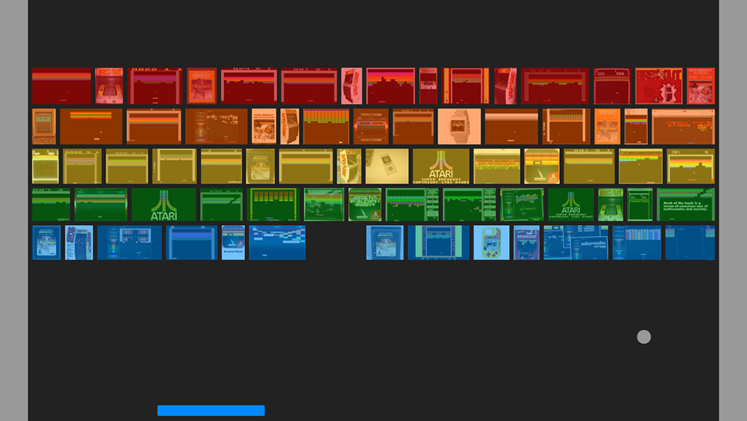

Atari’s Breakout Gameplay (2013)

# **Target Audience**

This game is for teenagers and above, as the youngest age group will have more understanding of the food they eat and calorie intake. Nutrition is a topic that is highly under-taught everywhere unfortunately, but we eat food everyday and other than “food gives energy”, the majority do not realise how the food eaten impact their body and could potentially increase health issues.

# **Learning Objectives**

The learning objectives are:

* Being able to categorise different foods into the correct food group.
* Learn the calorie values for major foods that will be consumed in an average person’s meal.

# **Market Research**

Malaria Game: Case Study

Two games were made to educate players on the topic of malaria. A mosquito game where the player plays as an Anopheles-malaria-transmitting mosquito through various environmental obstacles in order to suck blood from a human; and a parasite game where the player was to guide the malaria parasite to the human liver, then into a red blood cell, avoiding obstacles such as cytotoxic T-cells, natural killer cells, antibiotics, and macrophages (Lennon, 2006).

A case-study was conducted on a Filipino American aged 13 years, 10 months, and after playing both the games, the participant enjoyed them both but as both playthroughs were rather quick, some learning objectives were not fully cemented. However other learning objectives were achieved such as the participant’s likeness towards bats. If the feedback received was implemented and introduced as a regular occurance, then both games would be very successful in teaching new players about malaria (Lennon, 2006).

Nutrition Game: Quasi-Experiments

Nutrition education has been recognised as a crucial factor in promoting good health, and healthy eating habits need to be shaped in childhood as it can influence the normal growth of students and reduce chronic diseases (Yien, Hung, Hwang and Lin, 2011)..

A Taiwanese e-learning website was established to apply game-based learning approach to nutrition education and an quasi-experimental nonequivalent-control group design study was conducted which used five games to teach the four topics - “Knowledge of Eating Functions”, “Our Eating”, “Healthy Eating Habits” and “Tracking Eating Habits”, which was taught for 40 minutes each week for a month. This replaced the students’ physical education class, where 66 3rd graders of elemental school were split into two groups - an experimental group and a control group. By the end of the study, the learning achievement of students in the experimental group was significantly better than students in the control group (Yien, Hung, Hwang and Lin, 2011).

Nutrition Game: Pilot Study

A game patterned after Loteria - a popular pictorial bingo game in the Mexican-American community - was introduced to low-income families in Texas. The moderator of the game shows a card with a picture and tells a story or recites a rhyme to describe the picture. The players then put a token on their game boards if they have the picture. The cards had both English and Spanish and were used to play a variety of types of nutritional bingo. This was to test the effectiveness of a nutrition game to increase the servings of healthful foods (Piziak, 2012).

At the beginning and end of the school year, the parents of the 10,000 participants were to complete a questionnaire about food offered to the children throughout the week, and then the parents documented the number of times the children were served healthy foods. Teachers were instructed about the game and given basic nutrition counselling, and the game were played at least twice a week, and the children were encouraged to recite the rhymes that were on the cards as they were presented. The study showed no significant changes in dietary habits but feedback from teachers demonstrated that the game was important in promoting recognition of a variety of foods by children and the repetition of rhythms could be used to promote the importance of healthy foods (Piziak, 2012).

# **GUI and Environment**

Taken from the gov.uk site section of Eatwell, used to define government recommendations on eating healthily and achieving a balanced diet.

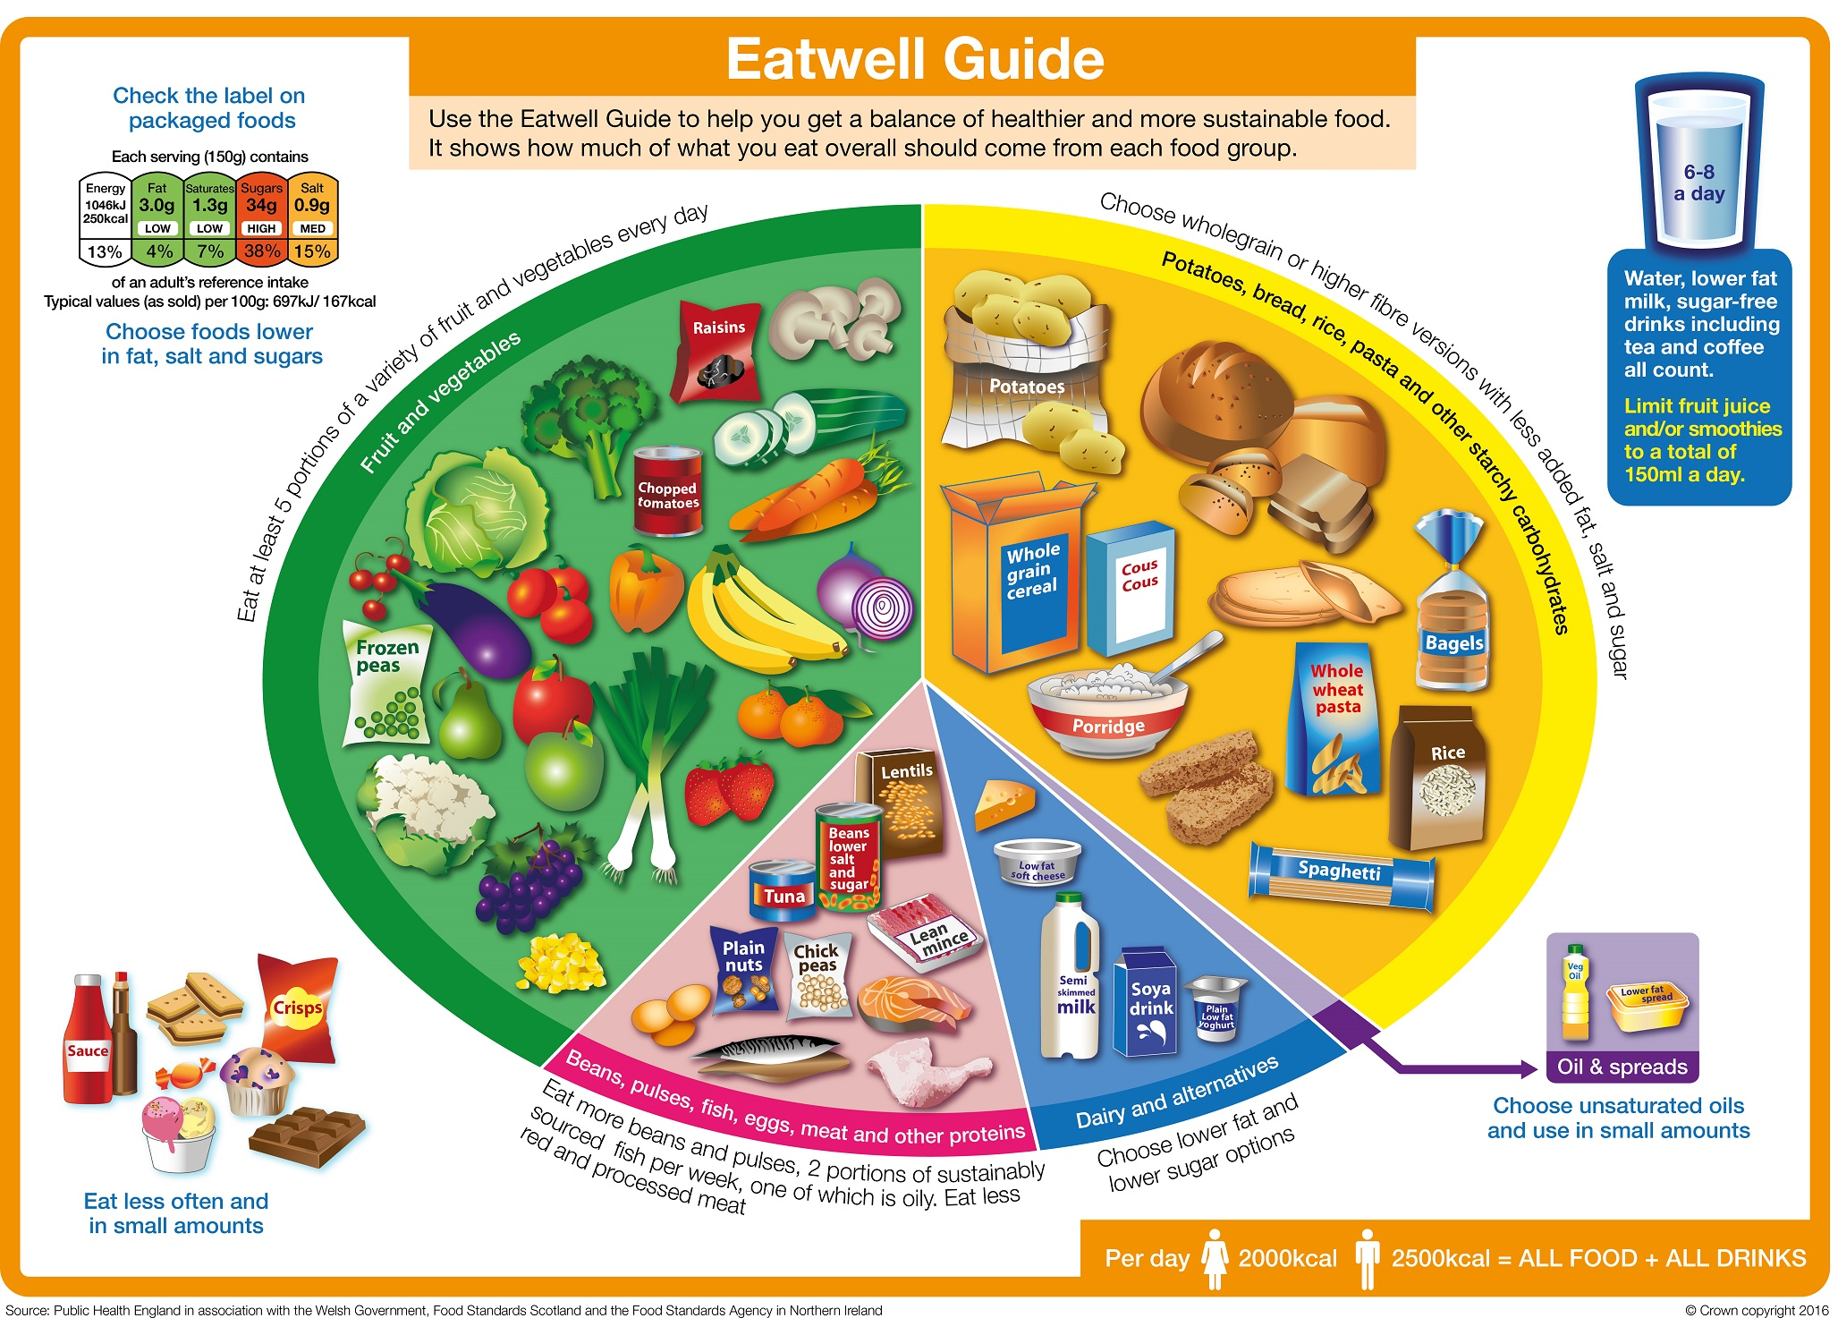

Gov.uk Eatwell Guide (n.d.)

In the reference photo:

* Fruit and Vegetables are green.
* Starches are yellow.
* Dairies are blue.
* Meats are red.
* Unhealthy Snacks do not have a colour, but will be referenced as purple in the game.

There will be additional elements to Nutrition Blocks that will be different than Breakout. Instead of just having the paddle, a little humanoid will be holding the paddle up and running around, bouncing the ball around to break the blocks.

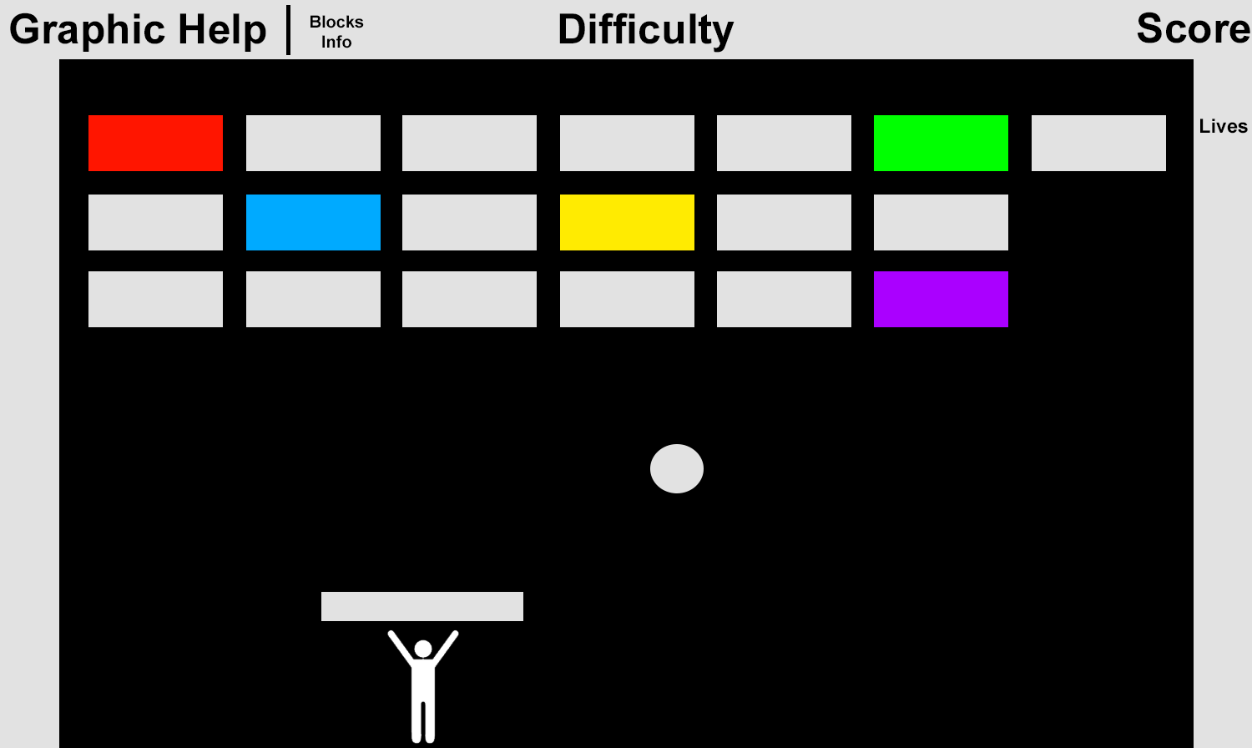

# **Player Mechanics**

The game will start with the default white ball and white blocks, scoring points. Then throughout the game, special coloured blocks will appear with the appropriate colour - representing fruits/vegetables, starches, dairies, meats, or unhealthy snacks.

Switching between the ball colours on PC will be set by these key bindings:

* A - White ball.
* S - Green ball for fruits/vegetables.
* D - Yellow ball for starches.
* Q - Blue ball for dairy.
* W - Red ball for meat.
* E - Purple ball for unhealthy snacks.

The player will be able to move the Paddle Human left and right with the arrow keys and be able to switch ball colours at any time during gameplay.

# **Interactions and Consequences**

This will be a single-player endless survival game with the goal being to get the highest score by keeping the Paddle Human alive as long as possible. As the game ticks on, the Paddle Human will slowly become thinner and thinner and the side effect of becoming thinner is becoming slower.

To “eat”, the player must destroy the blocks according to its colour otherwise it will bounce off and when destroyed, its food type, name, and point value will be displayed as an UI element, with the point value being the average calorie intake for that food for a meal portion. Therefore repetitive flashes of what was destroyed will slowly ingrain into the player.

When blocks are destroyed, they keep the Paddle Human fed and at a normal speed. The ball can touch the ground, however there will be a lives system of if the player is hit by the ball or does not eat enough, a life will be lost.

# **Game Structure**

The game will be made in Unity. There will be difficulty thresholds as the game ticks on and an image will be displayed, showing which keys to press to switch to which colour. As the difficulties progress, the image will fade out over time. Every time the player completes the wave, the player will respawn at the starting location.

1) Beginner:

* Blocks will show up as solid colours, letting the player learn colour placements keys.
* Default Blocks will have a 90% chance of appearing.
* The rest of the Blocks will each have a 2% chance of appearing.
* The ball speed is slow.

2) Easy:

* Blocks will show up as solid colours.
* Default Blocks will have a 70% chance of appearing.
* The rest of the Blocks will each have a 6% chance of appearing.
* The ball speed is faster.

3) Medium

* Blocks will show up as solid colours, with different foods on the side.
* Default Blocks will have a 50% chance of appearing.
* Each specialisation will each have a 2% chance of appearing.
* The ball speed is medium.
* Each of the coloured Blocks will split into 5 different specialisations.
  + The Green Block can now have broccoli, mushrooms, onions, apples, or bananas on its side.
* The points of each specialisation will adhere to its average single meal calorie value.
  + Fruits / Vegetables (USDA Branded Food Products Database, n.d.)

Broccoli - 34 calories

Mushrooms - 22 calories

Onions - 40 calories

Apples - 52 calories

Bananas - 89 calories

* + Starches

Bread - 265 calories

Potatoes - 77 calories

Rice - 130 calories

Pasta - 131 calories

Cereal - 393 calories

* + Dairy

Milk - 42 calories

Soy Milk - 54 calories

Cheese - 402 calories

Butter - 717 calories

Yoghurt - 59 calories

* + Meat

Eggs - 155 calories

Chicken - 239 calories

Beef - 250 calories

Beans - 347 calories

Tuna - 108 calories

* + Unhealthy Snacks

Chocolate - 546 calories

Muffins - 377 calories

Crisps - 536 calories

Candy - 535 calories

Soft Drinks - 51 calories

4) Hard

* Blocks will not show the solid colours and will still have different foods on the side.
* Default Blocks will have a 25% chance of appearing.
* Each specialisation will each have a 3% chance of appearing.
* The ball speed is fast.

The expected experience will be like playing Breakout while learning some nutrition through repetition and replay value.

# **Audio**

The sound effects in this game will not be much, like whenever the ball comes in contact with a block a sound is played, or when a line of blocks is cleared - effects to engage the player and provide extra information. They will be small and simple, taken from free sources like [FreeSound](https://freesound.org/) or [SoundBible](http://soundbible.com/), and edited with Audacity.

# **Future Work**

If the game is developed further professionally, special diets like vegetarian, vegan, halal can become available, also implementing fun little animations that will impede the paddle human like such as vomiting, having stomach cramps, or being affected by allergies.

Faeces could also be released from the body, and the faeces released would be according to how the player “ate”. Not “consuming” vegetables or starches will cause the paddle human to not have enough good fibre and will cause large painful faeces, which can then result in a hospital visit for laxatives if over a prolonged period, excessive sugar or infections causing diarrhea, or too much alcohol triggering the human self defense system of vomiting.

# **Individual Critical Appraisal**

The development of the game went well and I learnt a lot about different coding practices to develop an algorithm for endless block spawning. This integrated well with Unity and the way I developed it allowed for any number of blocks in the wave, the number of waves, the percentage spawn chance for each array element, and difficulty thresholds to be easily modifiable.

The comments I left for myself are extremely concise and this will allow me to pick up where I left off after a long period of time easily. As I was juggling other university projects, the development process of the game was in long and short bursts with several days or weeks gap, and I found that the comments I had left previously were confusing.

I feel I did leave the development of the game a little bit late, but I developed everything I said I would with a few exceptions - a percentage bar to show how many calories to eat from each food group, and the selection of special diets. They would be too difficult to develop in the short time period of 3 months, and they would not fit well with the current gameplay.

If I were to develop the game further professionally, I would not have to change much as the code is already there and works. I would change some small parts of the code to allow easier integration with other scripts and would not be relying on a lot of if boolean statements. The rest would be professional animations, vfx and sounds, models and sprites. The bugs will have to be fixed, but I’m not if some would be possible to fix without rebuilding the whole project or moving to another engine as some bugs occur due to Unity’s Physics system.

# **Game Development Bugs**

Several quality-of-life bugs happen when the ball hits the very edge of the paddle.

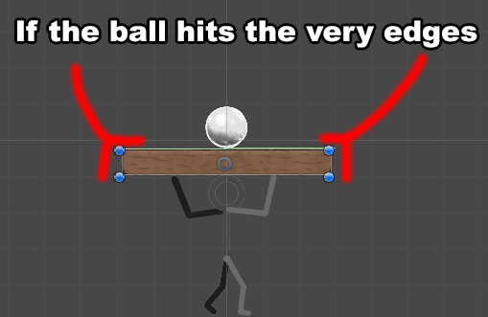

The ball’s current velocity can drop from a playable speed to an extremely slow, and currently there is no way to fix it as the problem originates from Unity’s inbuilt Physics system. Changing the paddle’s collider from a Box Collider 2D to an Edge Collider 2D reduces the chances of the ball hitting the edge, but still occurs (My Ball Slows Down, 2017).

Also, the ball can hit the Paddle Human in such a way that the Paddle Human is pushed back due to the force and until the Paddle Human comes to a natural stop, moving in either direction results in moving very slowly. On the topic of collisions, the ball can collide with the destroyable blocks in such a way that instead of flying close to a 45° angle, the ball will essentially fly horizontally making the gameplay just waiting for the ball to come back down to the player slowly.

To fix both problems, the player be hit by the ball on purpose, losing a life and respawning. However when respawning, there is a delay where the player cannot move even though in the code, the player is allowed to do so. In that short delay, attempting to move will make the player character spasm, and pressing the spacebar multiple times to “launch the ball” will increase the ball’s velocity that when the delay is over, the ball will shoot off in either massively increased speed or out of the game’s boundaries. The player can reset the game’s progress but it still feels extremely unfair to the player due to the loss of progress, difficulty setting, and score.

# **References**

Atari’s Breakout Gameplay (2013). [Online] Available:

<https://gizmodo.com/you-can-play-atari-breakout-on-google-image-search-and-504867660>

Lennon, J. (2006). Reports & Communications: Debriefings of Web-Based Malaria Games. Simulation & Gaming. Vol 37 (3), p. 350-356.

Yien, J-M., Hung, C-M., Hwang, G-J., Lin, Y-C. (2011). A Game-Based Learning Approach to Improving Students’ Learning Achievements in a Nutrition Course. Turkish Online Journal of Educational Technology. Vol 10 (2), p. 1-10.

Piziak, V. (2012). A Pilot Study of a Pictorial Bilingual Nutrition Education Game to Improve the Consumption of Healthful Foods in a Head Start Population. International Journal of Environmental Research and Public Health. Vol 9 (4). p. 1319-1325.

Gov.uk Eatwell Guide (n.d.). [Online] Available:

<https://www.gov.uk/government/publications/the-eatwell-guide>

My Ball Slows Down (2017). [Online] Available:

<https://community.gamedev.tv/t/help-my-ball-slows-down/16597/4>

USDA Branded Food Products Database, 100 grams (n.d.). [Online] Available:

<https://ndb.nal.usda.gov/ndb/search/list>

# **Appendix**

Calculating Calories -

<https://www.choosemyplate.gov/MyPlatePlan>

<https://www.nhs.uk/chq/pages/1126.aspx?categoryid=51>

Constipation - <https://youtu.be/0IVO50DuMCs>